CO5 CASE STUDIES

CASE STUDY 1:
A large hospital uses an AI-based diagnostic system to help doctors detect a rare disease (D) in patients based on the results of a medical test (T). The disease affects only 1 out of every 1000 people, meaning most patients are actually healthy. The diagnostic test is fairly accurate: if a patient truly has the disease, the test gives a positive result 95% of the time (sensitivity), and if a patient does not have the disease, it gives a negative result 90% of the time (specificity). However, the test can still make errors by producing false negatives or false positives. Suppose a patient undergoes the test and receives a positive result. Although the high test accuracy may initially suggest that the patient is likely to have the disease, doctors know that the disease is extremely rare, so this prior information must also be considered. Therefore, simply relying on the positive test result can be misleading, and Bayes’ Theorem is used to combine the disease prevalence, test accuracy, and observed evidence to calculate the actual probability that the patient has the disease after testing positive.
a) Identify the prior probability, conditional probabilities, and evidence in this scenario.
b) Using Bayes’ theorem, calculate the probability that a patient actually has the disease if the test result is positive.
c) Illustrate the bayes concept using python programming.
Case study 2:
Aadhaar biometric authentication — Bayesian analysis of fingerprint matching. UIDAI's Aadhaar Authentication API receives ~50 million biometric verification requests/day. A fingerprint match returns YES/NO. The matcher's reported quality:
- True Match Rate (TMR): P(match=YES | same person) = 0.99 (sensitivity).
- False Match Rate (FMR): P(match=YES | different people) = 0.0001 (10⁻⁴).
- Genuine claim rate: 99.9% of authentication requests are genuine (the person IS who they claim to be).
- Impostor claim rate: 0.1% are impostors trying to pass off as someone else.
For a YES match output, what's the probability the claim is genuine? For a NO output, what's the probability the claim is impostor?
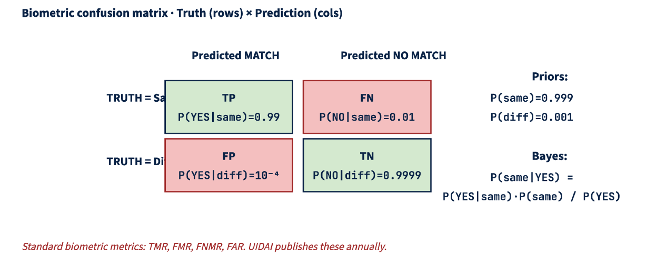
(a) Prior and likelihood analysis.
From the given information, identify the following probabilities:
- $P(same)$
- $P(diff)$
- $P(YES∣same)$
- $P(YES∣diff)$
- $P(NO∣same)$
- $P(NO∣diff)$
Draw a probability table and explain the significance of TMR and FMR in biometric authentication.
(b) Compute $P(genuine∣YES match)$.
Apply Bayes' theorem:
$$P(YES)=P(YES∣same)P(same)+P(YES∣diff)P(diff) \\ P(genuine∣YES)=\frac{P(YES∣same)P(same)}{P(YES)}$$
Show all calculations and interpret the result. What is the probability that a YES output corresponds to a genuine user?
(c) Compute $P(impostor∣NO match)$.
Using Bayes' theorem:
$$P(NO)=P(NO∣same)P(same)+P(NO∣diff)P(diff) \\ P(impostor∣NO)=\frac{P(NO∣diff)P(diff)}{P(NO)}$$
Calculate the posterior probability and explain what a NO output implies about the authenticity of the claimant.
(d) Python implementation.
Write a Python program to compute:
- $P(genuine∣YES)$
- $P(impostor∣NO)$
using the given values:
- $P(same)=0.999$
- $P(diff)=0.001$
- $P(YES∣same)=0.99$
- $P(YES∣diff)=0.0001$

CASE STUDY 3:
A warehouse robot uses an AI-based Bayesian Network to navigate safely by detecting obstacles using sensor inputs. The robot considers three variables: Sensor Signal (S), which indicates a possible obstacle; Obstacle Present (O), which represents whether an obstacle is actually present; and ActionTaken (A), which determines the robot’s response such as stopping or moving. The Bayesian Network is represented as SensorSignal → Obstacle Present → ActionTaken, where the robot uses sensor evidence and probabilistic reasoning to estimate the likelihood of an obstacle and then makes an appropriate navigation decision under uncertainty.
- Using the Bayesian Network shown below, compute the joint probability where P(O=True, T=False, D= true, L= true, R= False). Show beysian network factorization.
- describe the Bayesian Network and explain the role of each node and directed link.
b) Explain how conditional probability tables (CPTs) are used in this Bayesian Network.

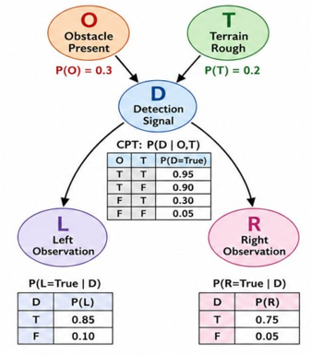
.
Case Study 4: Weather Prediction Using Hidden Markov Model (HMM)
A meteorological department wants to predict the actual weather conditions (Rainy or Sunny) for three consecutive days. However, the true weather cannot be observed directly. Instead, the department records whether people carry an umbrella or not.
The weather is modeled as a Hidden Markov Model (HMM) with two hidden states:
- Rainy (R)
- Sunny (S)
The initial probabilities are:
State | Probability
Rainy | 0.6
Sunny | 0.4
Transition Probability Matrix (Weather Change)
From \ To | Rainy (R) | Sunny (S)
Rainy (R) | 0.7 | 0.3
Sunny (S) | 0.4 | 0.6

Emission Probability Matrix
Observation | P(· | Rainy) | P(· | Sunny)
Umbrella (U) | 0.9 | 0.2
No Umbrella (N) | 0.1 | 0.8

Observation Sequence
$$O=(U, U, N)$$
where:
- U = Umbrella observed
- N = No Umbrella observed
The department wants to determine the most likely sequence of hidden weather states corresponding to the observations using the Viterbi Algorithm.

Q1. Identify the hidden states and observable states in the given Hidden Markov Model.
Q2. Using the transition matrix, calculate the probability that the weather changes from:
a) Rainy to Sunny
b) Sunny to Rainy
c) Rainy to Rainy
Q3. Compute the Day-1 Viterbi probabilities for both hidden states using the initial probabilities and the observation $U$.
Q4. Construct the Viterbi dynamic programming table for Day-2 and Day-3 observations and determine the maximum probability associated with each state.
Q5. Write a Python program to implement the Viterbi Algorithm for the given HMM and determine the most likely hidden weather sequence corresponding to the observation sequence $\left(U , U , N\right)$.
Case Study 5: Robot Navigation Using Hidden Markov Model (HMM)
A mobile robot is deployed inside a smart warehouse containing two rooms (A and B). The robot cannot directly determine its current location because its camera is temporarily disabled. Instead, it relies on a sensor that detects whether an object is present or absent in the room.
- Room A usually contains stored objects.
- Room B is mostly empty.
The robot may remain in the same room or move to the other room at each time step. The movement behavior follows a Hidden Markov Model (HMM).
The robot records the following sensor observations over three time periods:
$$O=(P, P, N)$$
where:
- P = Object Present
- N = Object Absent
The objective is to determine the most likely sequence of rooms visited by the robot using the Forward and Viterbi Algorithms.
Initial State Probabilities
State | Probability
Room A | 0.6
Room B | 0.4
Transition Probability Matrix
The probability of moving between rooms is given below.
From \ To | Room A | Room B
Room A | 0.7 | 0.3
Room B | 0.4 | 0.6

Emission Probability Matrix
The probability of observing sensor readings in each room is shown below.
State | P (Present) | N (Absent)
Room A | 0.8 | 0.2
Room B | 0.3 | 0.7

Observation Sequence
$$O=(P, P, N)$$
Sub Questions
Q1. Identify the following components of the Hidden Markov Model used in the robot navigation problem:
a) Hidden States
b) Observations
c) Initial State Probabilities
d) Transition Matrix
e) Emission Matrix

Q2. Using the transition probability matrix, calculate the following probabilities:
a) Probability that the robot remains in Room A.
b) Probability that the robot moves from Room A to Room B.
c) Probability that the robot moves from Room B to Room A.
d) Probability that the robot remains in Room B.
Q3. Using the initial probabilities and the first observation (P), compute the Forward probabilities at t = 1:
Q4. Apply the Forward Algorithm for the observation sequence
$$\left(P , P , N\right)$$
Q5. Write a Python program to implement the Viterbi Algorithm for the given HMM and determine:
a) The most likely sequence of rooms visited by the robot.
b) The probability of the best path.
c) Interpret the result obtained from the observation sequence.

Case Study 6: Student Daily Mood Prediction using Markov Chain
A student wants to predict their emotional state for tomorrow based on how they feel today. The student's mood can be classified into one of three states:
- Happy (H)
- Neutral (N)
- Sad (S)
Based on historical observations, the following transition probabilities have been obtained.
Transition Probability Table

Current State (Today) | Happy (H) | Neutral (N) | Sad (S)
Happy (H) | 0.5 | 0.3 | 0.2
Neutral (N) | 0.4 | 0.4 | 0.2
Sad (S) | 0.3 | 0.3 | 0.4

Sub Questions
Q1. Identify the following components of the Markov Chain:
a) State Space b) Transition Matrix c) Initial State Vector
Q2. Using the transition probability matrix, calculate the following probabilities:
a) Probability that a Happy student remains Happy tomorrow.
Q3. If the student is Happy today, determine the probability distribution of moods after one day.
Q4. Determine the probability distribution of moods after two days if the student is Happy today.
Find the probabilities of being: Happy, Neutral, Sad after two days.
Q5. Write a Python program to:
- Define the transition matrix.
- Compute the mood distribution after one day.
- Calculate the steady-state distribution of the Markov Chain.

